Tuesday May 5th 2020
English
Water Cycle
Please watch the PowerPoint attached to the email. ‘Water Cycle Diagram PowerPoint’.
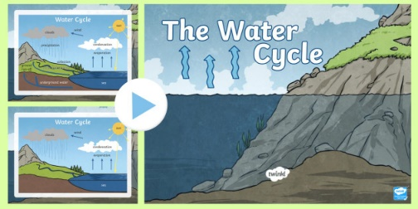
Reading Comprehension: The Water Cycle Reading Comprehension Activity. Please select the worksheet for your year group. If possible, please print off the sheets, trim and stick in your homework book. Please use the heading ‘The Water Cycle’. (The answer sheets are attached.)
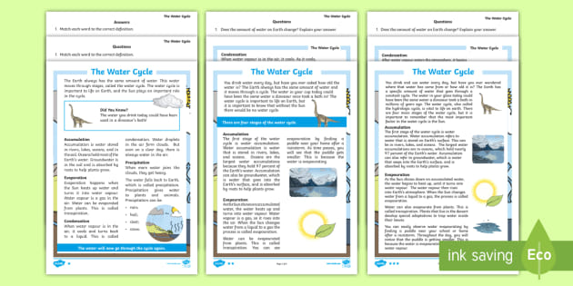

Maths
- White Rose Maths Lesson 2 (Can be accessed via school website)
Year 3- – Subtracting Fractions
https://whiterosemaths.com/homelearning/year-3/
Year 4: Halves and Quarters
https://whiterosemaths.com/homelearning/year-4/
- Times table book.

- -I Can Do Maths. (10-15 minutes)

RE: Humanism - Influential Thinkers
See attached folder for PowerPoint and worksheet. (This work will require the help of an adult and the discussion is a vital part of the learning. Please use the PowerPoint attached as a talking point.)
Humanism: Read through and discuss the information about secular humanism and atheism on the Lesson Presentation: Influential Thinkers:
Children read about George Eliot and highlight the key ideas. The children carefully choose 6 key ideas and write them inside the keys. They then complete a sentence stating whether or not they agree with those ideas
Don’t forget our daily expectations:
- Regular reading
- Regular learning and practising both spellings and times tables
- Watching Newsround when possible
- Daily Staying Active activities e.g. ‘Let’s keep busy’ Healthy Mind and Body: physical activity and creative ideas (These can also can be accessed on our Home Learning tab on the school website)
- Regular listening to The Lion the Witch and The Wardrobe read by Mrs Bailey and Ms Tunstall on our You Tube Channel.
Please note: Chapter 7, read by Ms Tunstall, will ready on tomorrow.

