Big Write
Thursday 7th May

- Today you are going to write a non-chronological report (a report that doesn’t need to be in time order) about The Creature in the Marshmallows film clip.

Firstly, watch the film again and take notice of The Creature. https://www.literacyshed.com/marshmallows.html

Here are some screenshots of The Creature.
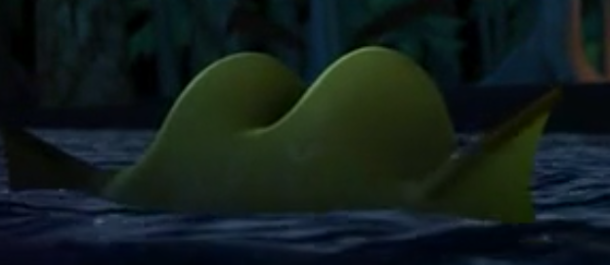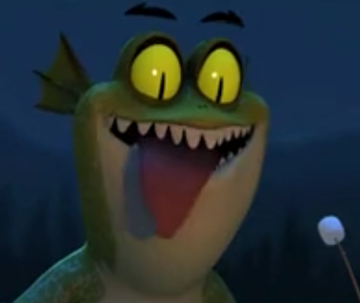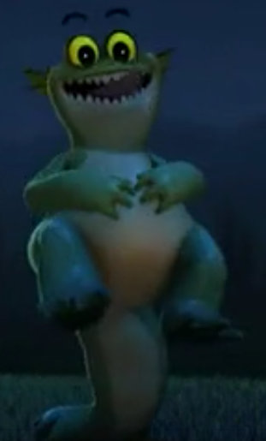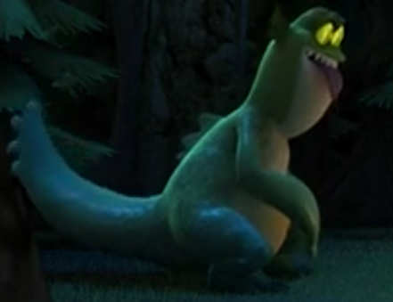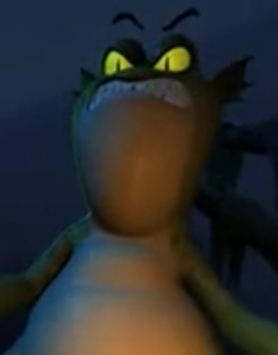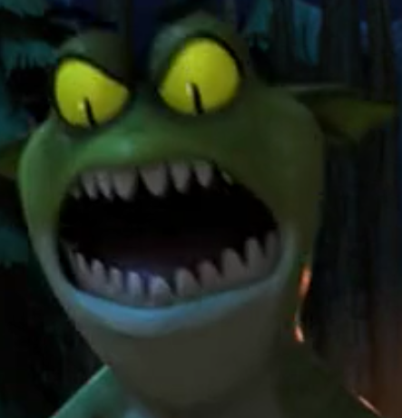

Secondly, pretend you are the expert on this type of creature.
Make up a name for this type of creature e.g. an elephanttosis or maybe a doggon. This is the name of the TYPE of creature like: dogs, cats, elephants, spiders, bears etc

Now, please read this example of a non-chronological report for a made-up animal called a donriphant.

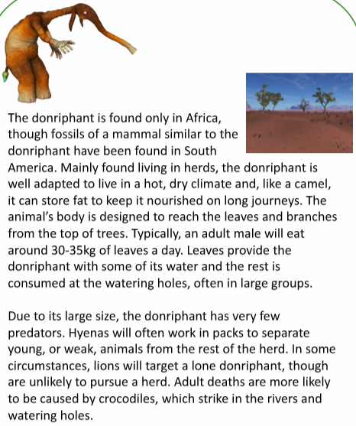

Next, in your purple books, write the long date and underline it. Miss a line. Now write the title:
A Non-Chronological Report of A (write your made-up creature type)

Before you begin your report, look at these words and think how you might include them in your report. They will make you sound like an expert as they sound technical. It might be helpful to discuss this with your parent. Only choose some of these words and you can of course alter them or use similar words.
Jot down your ideas in your purple books so that you don’t forget your ideas.

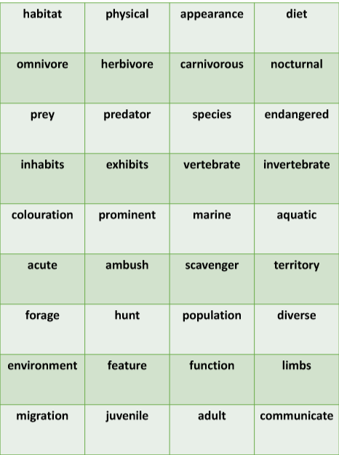

Finally, it is now time to write your own non-chronological report.

Here is how to set out your report and some top tips to help you:

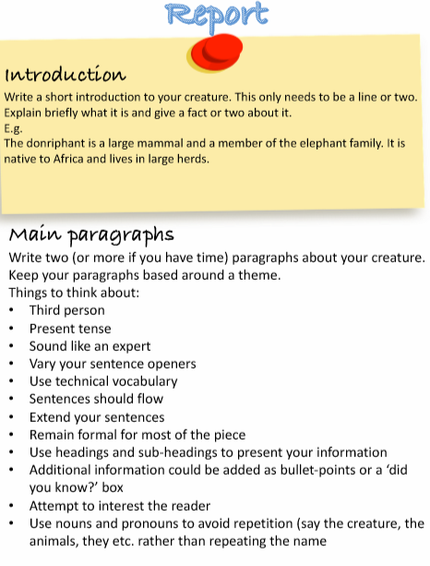

Try your best and most importantly, have fun! This is a Big Write where I think an illustration is a must!
Love,
Ms Tunstall

