Art

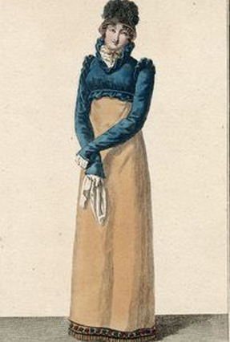
Over the past three weeks we have been looking at different parts of Georgian fashion.

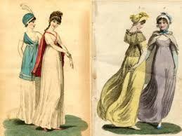
We have learnt about the style of dress the Women wore - the Empire line with the high waist and gentle flowing style, the delicate floaty fabrics used and the delicate patterns. We have learnt about the warm layer of clothing worn to compliment the dress - the shawls or jackets. We have also looked at their hair and the lavish styles they wore at the beginning and how they became more natural towards the Regency era.

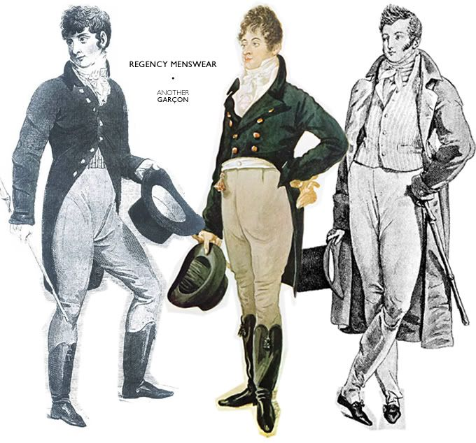
We have also looked at men’s fashion and how that changed throughout the Georgian era, from short trousers to longer styles. Their hair following that of the women’s styles with tight curled wigs moving to a more natural shorter style.

Your Task
This week I would like you to read back through the last three weeks notes and design either an outfit comprising of dress, overcoat and hairstyle for a woman in the Regency times or a suit and hair style for a Georgian man.
I would like you to research and see what if any accessories either would have to complete their outfit. Maybe a bag for the lady or a top hat and cane for the gentlemen.

When you are designing your outfit think about all the questions I have asked previously -

Where is the waistband - waist, higher, lower?
What colour is the item or items of clothing?
What detail - embroidery, pattern, bows, ribbons, buttons etc?
Sleeve length – long, short, puffed, fitted?
Length of skirt or trouser leg – long, mid length, short, knee length?
Type of fabric – light and floaty, stiff to hold its shape?
How is the coat or shawl worn?
Does it have sleeves, a collar, a hood?
What length is the garment?
Is it fitted and tailored or is it draped?
What detail is in the pattern or edging?
Does it have buttons, a tie, a zip?
What colours were used?

Please label your design telling me what colours, fabrics, patterns, what the jacket is called for example the spencer jacket. I would like you to tell me what accessories they have in their hair or they are carrying to complete the outfit. When you are labelling the sketch please think about words such as draped, tailored, fitted, flowing, rich.

