Whole Class Reading - Paddington’s Post 2

Using the letter for Aunt Lucy in the book, or find attached a photo of the letter.

Remember to answer the questions in full sentences. i.e who is the author? ‘The author of the story is…’
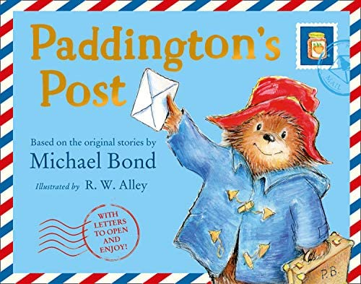

WHat is the name of the road Paddington is living on?
___________________________________________________________________________________________________________________________________________________________________________________________________________________________

What is the last name of the family he is living with?
___________________________________________________________________________________________________________________________________________________________________________________________________________________________

How is Paddington feeling about his new home and how do you know (try to use because)?
___________________________________________________________________________________________________________________________________________________________________________________________________________________________

