Whole Class Reading - Paddington’s Post 1

Remember to answer the questions in full sentences. i.e who is the author? ‘The author of the story is…’
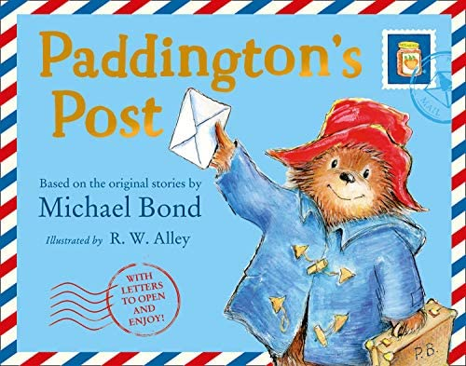

Who is the author of the story?
___________________________________________________________________________________________________________________________________________________________________________________________________________________________

Where did Paddington Bear get his name from?
___________________________________________________________________________________________________________________________________________________________________________________________________________________________

What number house did Paddington’s new family live in?
___________________________________________________________________________________________________________________________________________________________________________________________________________________________

