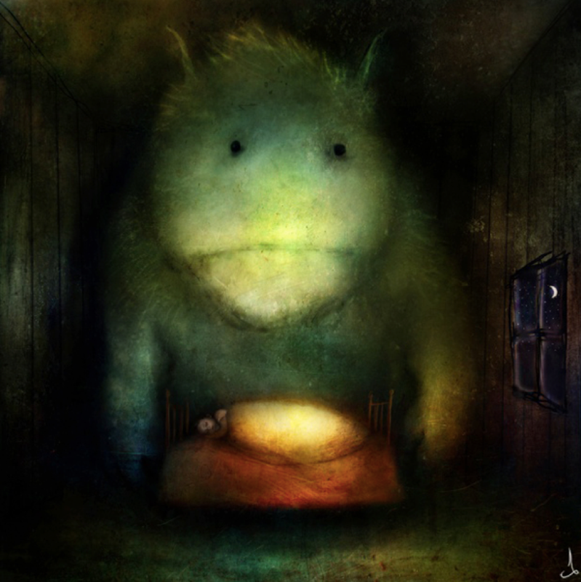
Question time!
Where do you think the Dreamgivers come from?
What do you think determines whether the child has a nightmare or a dream?
Why do we sometimes remember our dreams, but often forget them?
Many people believe that our dreams often have hidden meanings. Do you believe this is true?
Can you remember a dream you have had before? Have you ever had the same dream twice?
Do you think the Dreamgivers are friendly?
Where do you think our dreams come from?
What is the difference between a dream and a nightmare?
Have you ever had dejavu? Do you believe it is significant?
Follow the link below and watch the section ‘What are free verse poems?’
https://www.bbc.co.uk/bitesize/topics/z4mmn39
Can you write your own free verse poem about The Dreamgivers? You can ‘magpie’ and adapt some ideas from the sections below if your stuck but try to use your own creative ideas too - and don’t forget to include similes and metaphors (onomatopoeia/personification if you can) in your piece.

Narrative ideas
Every night they would come. They were never seen or heard, but they were always there.
All around the world, as the sun faded beyond the horizon, and the gentle sound of children’s snores could be heard as they slept in their beds, the Dreamgivers would come.
Quieter than a field mouse and stealthier than a midnight fox, they would gently lean over their sleeping victims and whisper their curious melody into unhearing ears.
This is how dreams are given, whether they be peaceful and tranquil fantasies, or whether they torment the sleeper as they are confronted with their deepest, darkest fears…
I wonder what this child would dream of tonight?

Sentence challenge
Can you use a series of questions in your poem? Remember to use a question mark!
E.g. Was there something in my bedroom? I was sure I had heard muffled footsteps, or was I perhaps still dreaming?

Sick sentences!
These sentences are ‘sick’ and need help to get better. Can you help? Could you add an adverb?
There was a big big thing in the room. It had fur and small eyes. It stood there really still.

