Monday May 4th 2020
English
Purple Mash Story The Settlers- Chapter 7 (last chapter)
PDF of Chapter 7 Multiple choice questions available to print off and to be completed in your purple homework book. (If you use this method, please indicate in the message box on the app.)
- This week we will be working on sequencing the events in the story and SPAG (Spelling, Punctuation and Grammar) activities. These will start tomorrow.
Go to 2do and read the online story, then complete the multiple choice questions. This is the last chapter of this book.

Maths
- White Rose Maths Lesson 1 (Can be accessed via school website- see Home Learning-Whole School Learning-White Rose Maths-Year 3 or 4, Summer Term Week 3 commencing 4/5/20)
Year 3- – Convert pounds and pence
https://whiterosemaths.com/homelearning/year-3/
Year 4: Multiply 2 digit numbers by 1 digit numbers
https://whiterosemaths.com/homelearning/year-4/
- Times table book. (unless finished) Please go to Doodle Tables and spend 5-10 minutes practising.
Times table test. Here are some ideas to help make learning your tables fun!
- 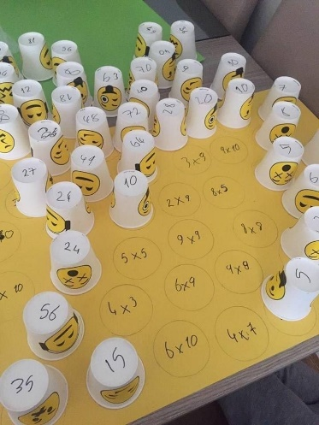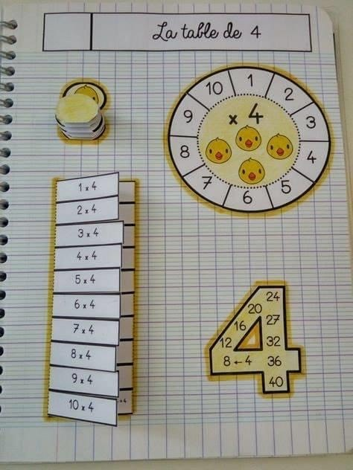
Year 4: Please write out your 9 times table in your book, 1-12
Then write it out again backwards.
Year 3: Please write out your 2 times table in your book, 1-12
Then write it out again backwards. (complete in own time this week)
Get someone to test you and write it down in your book.

-I Can Do Maths. (10-15 minutes- to be completed as suits).

Computing
- Purple Mash :2animate
A 2do task has been set. Today I would like to continue from last week’s animation. You will find this in your ’MY WORK’ folder. So we will create an animated picture that continues from the rain falling to the ground. (If you want to start again, that’s up to you!)
Follow this:
- The rain has fallen
- There are puddles of water on the ground
- The sun is shining
- The water is evaporating back into the sky. (think about how you can show this-the sun will stay in the picture.)
- White Clouds are gathering because the water has vaporised. (turned into gas)
You will need to use the tabs on the left hand side of the screen to pick different effects, including sounds. You can add the number of frames at the top of the screen, so that the sun starts to shine, puddles can start to evaporate slowly, then you can add more and more clouds in each frame. By the end of the animation you will have lots of white puffy clouds in the sky. There is a video guide available with full instructions.

- French -: The topic this week is school. Please watch the PowerPoint ‘La Salle de Classe’ (attached in today’s email) and practise saying the words in French. I have also added some notes to help you pronounce them correctly.
La sale de classe-la sal der class
Le professeur- ler professor
L’instructrice-lunstructreese
Un tableau noir-un tablow nowar
Un tableau blanc- un tablow blong
Une table-oone tabler
Une chaise –oon shez
Une porte-oone porte
Un placard ou armoire- un placar oo un armwa
Une pendule-oone pondool
Un ordinateur- un ordinatterre
Un megnetaphone-un megnatterfon

- Please watch the video ‘Daily School Routines in France.’(5 minutes)
. https://www.bbc.co.uk/bitesize/clips/zg8b4wx
It may sound tricky to understand at first, but the more you watch it the better.

Don’t forget our daily expectations:
- Regular reading
- Regular learning and practising both spellings and times tables (don’t forget Doodle Tables!)
- Watching Newsround when possible
- Daily Staying Active activities e.g. ‘Let’s keep busy’ Healthy Mind and Body: physical activity and creative ideas (These can also can be accessed on our Home Learning tab on the school website)
- Regular listening to The Lion the Witch and The Wardrobe read by Ms Tunstall on our You Tube Channel.
Please see our school website for the links.

